LOYOLA JESUIT SECONDARY SCHOOL
2026 MALAWI SCHOOL CERTIFICATE OF EDUCATION MOCK EXAMINATIONS

PHYSICS
DATE: _________________ Subject Number: M164/I
_{Time allowed: 2 hours}
PAPER I
(100 marks) Instructions
- This paper contains 17 printed pages. Please check.
Question Number | Tick if  answered | Do not write in these columns
1
2
3
4
5
6
7
8
9
10
11
13
- Fill in your Examination Number at the top of each page.
- This paper contains two sections, A and B. In Section A there are ten short answer questions while in Section B there are three restricted essay questions.
- Answer all the thirteen questions in the spaces provided.
- Use of electronic calculators is allowed.
- The maximum number of marks for each answer is indicated against each question.
- In the table provided on this page, tick against the number of the question you have answered.

Turn over
Section A (70 marks)
Answer all the ten questions
- a. Define the term electromagnetic wave.
___________________________________________________________________________________________________________________________________________________________________(1 mark)
b. Describe the relationship between the frequency, wavelength and energy produced by electromagnetic waves.
____________________________________________________________________________________________________________________________________________________________________________________________________________________________________________________(2 marks)
c. Figure 1 shows dots made on a ticker tape pulled by a trolley through a ticker timer.
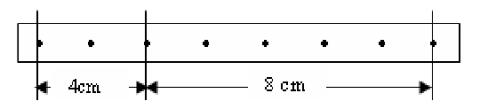
Figure 1.
Describe the motion of the trolley if the frequency is 50Hz.
____________________________________________________________________________________________________________________________________________________________(2 marks)
- a. Explain two properties of liquid pressure
_______________________________________________________________________________________________________________________________________________________________________________________________________________________________________________________________________________________________________________________________________________________________________________________________________________________(4 marks)
b. Explain how heating silicon enable it to conduct electricity
_______________________________________________________________________________________________________________________________________________________________________________________________________________________________________________________________________________________________________________________________________________(3 marks)
c. Briefly explain how a piece of iron can be magnetized by stroking
_______________________________________________________________________________________________________________________________________________________________________________________________________________________________________________________________________________________________________________________________________________(3 marks)
- a. Define the internal resistance of the cell
___________________________________________________________________________________________________________________________________________________________________(1 mark)
- A battery of e.m.f 7.3 V and internal resistance of 0.3 ohms is connected in series with a resistor of resistance 9.5 ohms. Determine
- The current in the circuit

(2 marks)
- Lost volts from the battery

(1 mark)

- Explain how constructive wave interference occurs
____________________________________________________________________________________________________________________________________________________________________________________________________________________________________________________________________________________________________________(2 marks)
- Figure 2 is a diagram showing a permanent of bar magnet being moved towards a coil. Use it to answer the questions
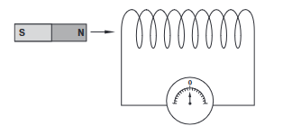
Figure 2

Fi
- (i) As current is being induced in the coil, what type of polarity is formed at end Y of the Coil?
__________________________________________________________________________( 1 mark)
- Explain how to determine the direction of the induced current in a coil, when a magnet moves into the coil
_____________________________________________________________________________________________________________________________________________________________________________________________________________________________________________(2 marks)
- Explain why a gas bubble released at the bottom of the lake grows in size as it rises to the surface of the lake.
_________________________________________________________________________________________________________________________________________________________________________________________________________________________________________________________________________________________________________________________________________________________________________________________________________________(3 marks)
- a. A convex lens produces a real image of an object and the image is 3 times the size of the object. The distance between the object and the image is 80 cm. Calculate the focal length of the lens

(3 marks)

b. Explain how the length of an inclined plane affects its mechanical advantage
________________________________________________________________________________________________________________________________________________________________________________________________________________________________________________________________________________________________________________________________________________________(2 marks)
c. Figure 3 shows a detector of radiation
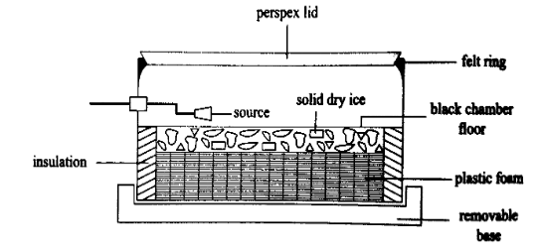
Figure 3
- Identify the instrument above.
_______________________________________________________________________(1 mark)
- How does the instrument work to measure presence of radiation?
___________________________________________________________________________________________________________________________________________________________________________________________________________________________________________________________________________________________________________________________________________________________________________________________________(3 marks)

- a. Figure 4 shows a circuit with some electronic device in use.
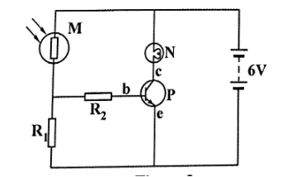
Figure 4
- Name the device M and P
M: _________________________________________________________________(1 mark)
P: __________________________________________________________________(1 mark)
Explain how part P operates as a light operated switch in the circuit during bright light
________________________________________________________________________________________________________________________________________________________________________________________________________________________________________________________________________________________________________________________________(3 marks)

- Calculate the height of a water column which exerts its base the pressure as 70 cm column of mercury. (Density of mercury is 13.6 g/cm³ and density of water is 1 g/cm³)

(3 marks)
- Construct a fixed resistor using resistor color codes with the value of 25 kΩ ± 10%

(1 marks)
b. (i) Explain briefly how water behaves as temperature decreases from 4⁰C to 0°C
_________________________________________________________________________________________________________________________________________________________________________________________________________________________________________________(2 marks)
(ii) A body of mass 400g tied to string, is rotated in horizontal circle of radius 1.2m at 2 Hz. Calculate the tension developed in the string

(3 marks)

- a. Figure 5 is a graph of force against extension.
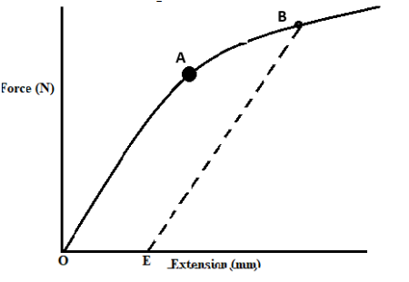
Figure 5
Describe the extension of the spring as illustrated from the graph
_______________________________________________________________________________________________________________________________________________________________________________________________________________________________________________________________________________________________________________________________________________________________________________________________________________________(3 marks)
- A motorcycle and its rider have a mass of 500 kg. When moving on a level road at 20 m/s the rider disengages the gears, switches the engine off and come to rest after 50 m. Calculate:
- Retardation

(2 marks)
- The average frictional force that stops the rolling motorcycle

(2 marks)
- a. State the principle of conservation of mechanical energy
_______________________________________________________________________________________________________________________________________________________________________________________________________________________________________________________(1 mark)
b. A gas occupies a volume of 2 m³ when its pressure is 1140 mmHg and its temperature is 27°C. What volume would it occupy at standard temperature and pressure (0°C and 760mmHg)?

(3 marks)
- Explain the mutual induction.
____________________________________________________________________________________________________________________________________________________________________________________________________________________________________________________________________________________________________________________________________________________________________________________________________________________________________________________________________________________________________(3 marks)
(ii). Explain how an echo can be used to determined the depth of the sea
_________________________________________________________________________________________________________________________________________________________________________________________________________________________________________________________________________________________________________________________________________________________________________________________________________________(3 marks)
- a. Figure 6 is a diagram showing waves on a rope xy．
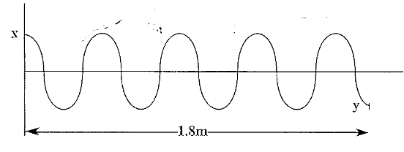
Figure 6
If the rope xy is swung up and down 20 times in 2 seconds, calculate the average speed of the wave.

(3 marks)
  - Explain how a micrometre screw gauge can be used to measure the thickness of a paper.
____________________________________________________________________________________________________________________________________________________________________________________________________________________________________________________________________________________________________________________________________________________________________________________(3 marks)

- In one particular experiment, the mass of the trolley was kept constant. The time t for the trolley to move a distance of 1.0 m from rest was determined for various values of the pulling force F. The acceleration a was calculated using the s=1/2at² where s=1.0 m. The following values were obtained.
Force applied (N) | 0.40 | 0.60 | 1.20 | 1.60 | 2.00
Acceleration (m/s²) | 0.06 | 0.22 | 0.43 | 0.57 | 0.74
Table 1

Plot a graph of force against acceleration
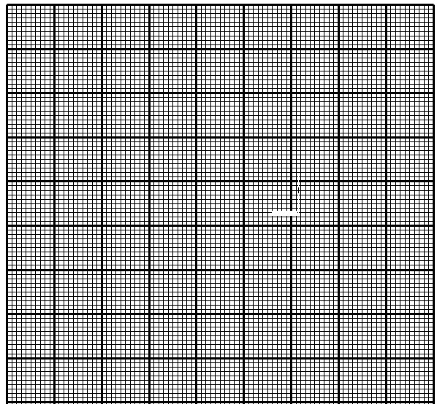
(3 marks)

Section B (30 marks)
Answer all the three questions in this section in the spaces provided.
- a. Figure 7 is a diagram of alternating current () generator
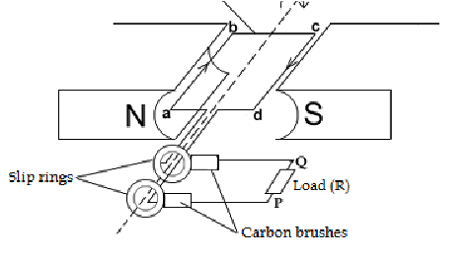
Figure 7
Explain how an alternating current (a. c) generator works
______________________________________________________________________________________________________________________________________________________________________________________________________________________________________________________________________________________________________________________________________________________________________________________________________________________________________________________________________________________________________________________________________________________________________________________________________________________________________________________________________________________________________________________________________________________________________________________________________________________________________________________________________________________________________________________________(5 marks)

b. With the aid of labelled diagram describe how the mass of an object can be determined using the principle of moments.

______________________________________________________________________________________________________________________________________________________________________________________________________________________________________________________________________________________________________________________________________________________________________________________________________________________________________________________________________________________________________________________________________________________________________________________(5 marks)
- a. Using a truth table, describe how a NAND gate works.

________________________________________________________________________________________________________________________________________________________________________________________________________________________________________________________________________________________________________________________________________________________(5 marks)
b. Explain how p-type semiconductor can be produced using the doping method.
________________________________________________________________________________________________________________________________________________________________________________________________________________________________________________________________________________________________________________________________________________________________________________________________________________________________________________________________________________________________________________________________________________________________________________________________________________________________________________________________________________________________________________________(5 marks)
- a. With the aid of a labeled diagram, describe the problem of short sight in human eye

____________________________________________________________________________________________________________________________________________________________________________________________________________________________________________________________________________________________________________________________________________________________________________________________________________________________________________________________________________________________________(5 marks)
b. With the aid of a well labeled diagram, describe the refraction of water wave as they travel from shallow to deep region

________________________________________________________________________________________________________________________________________________________________________________________________________________________________________________________________________________________________________________________________________________________________________________________________________________________________________________________________________________________________________________(5 marks)
END OF QUESTION PAPER
NB: This paper has 17 pages.

